Module 9: Hypothesis Testing-Concepts and Applications

Dr. P.K.Viswanathan, Professor, Great Lakes Institute of Management

Introduction:

Managers have to make decisions with minimum risk in an environment characterized by uncertainty. Acceptance or rejection of a decision depends on acceptance or rejection of a hypothesis. For example, a marketing manager is facing a decision whether to introduce a new product in the market or not. If his company could get a market share of 15 percent or more, then the new product would be introduced in the market. A suitable hypothesis formulation and testing it would help the manager take the right decision. This module covers the various tests of hypothesis that are useful in making sound decisions.

9.1 Statistical Hypothesis-A Conceptual Framework

What is a Statistical Hypothesis?

A statistical hypothesis is an assumption made in the form of a statement about population parameter. It may or may not be true. The manager has to ascertain the truth of the hypothesis. Consider the following example.

Statement 1: Not more than 20% of the adults watch children’s program in the television.

Statement 2: More than 20% of the adults watch children’s program in the television.

First, it should be noted that these two hypotheses cannot be simultaneously true. Only one of them will be true. Likewise, these two hypotheses cannot be simultaneously false. Only one of them will be false. The acceptance or rejection of a particular hypothesis leads to the acceptance or rejection of a particular decision. Statement 1 given above is called the Null Hypothesis (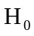). Statement 2 is called the Alternative Hypothesis (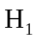). The decision maker normally formulates the null hypothesis with a view to getting it rejected. The null hypothesis is in a way the negation of the truth. The decision maker in his mind wants the alternative hypothesis to happen.

Supposing the two hypotheses stated above are in the context of an advertising manager who has to decide whether to invest in a new advertising campaign or not. His decision depends upon the outcome of the two hypotheses. Let us say that if not more than 20% of the adults watch children’s program in the TV, then it is not viable for the company to make investment in the campaign. If statement 1 is correct, the advertising manager will not invest in the new advertising campaign. If statement 2 is correct, he will invest in the new campaign. Therefore, the acceptance or rejection of either of the hypotheses enables the advertising manager to take the right decision.

The example that is used here highlights the role of statistical hypothesis in the context of decision-making. To put it succinctly, statistical hypothesis is a statement about the population parameter and in this example, the advertising manager makes a statement about the population proportion of adults watching children’s program in the television. He is not simply making a statement and stopping there; but formulates two hypotheses and then basing his final decision on the outcome of these hypotheses. The moral of the story is “statistical hypothesis is decision oriented”.

The Type I and Type II Errors

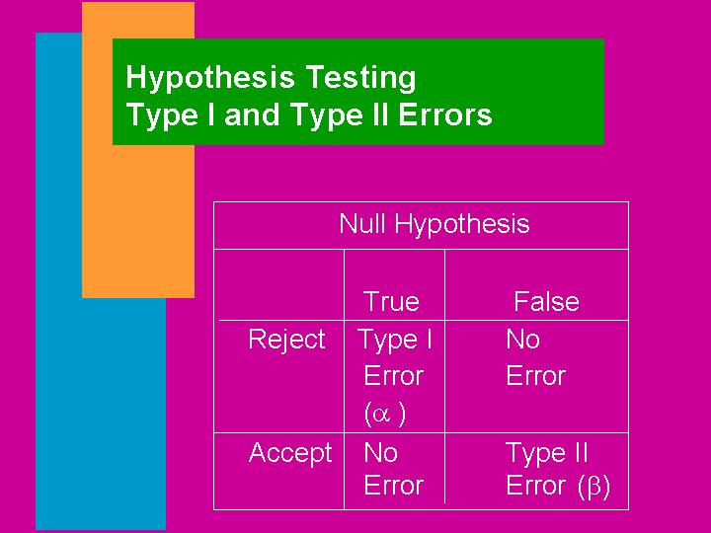

If you go through the example discussed in the previous screen, you will realize that the advertising manager is perhaps testing the hypotheses using sample survey data of the target audience collected from the adult population watching children’s program in the television. So, the manager is taking some risk in his decision to invest in the campaign. As you know that the sample data always contain some element of uncertainty and therefore it is not possible for the manager to be 100 percent certain that he has made the right decision. In a way the manager makes two types of errors. See the diagram above.

Type I error says that you reject the null hypothesis when it is true. Type II error says that you accept the null hypothesis when it is false. Strictly speaking you don’t accept the null hypothesis. When you cannot reject the null hypothesis, it only means that the sample evidence does not warrant rejection of the null hypothesis. At any rate in practice, using the terminology “accept the null hypothesis” helps you take the right decision. This little bit of dilution in terminology is permitted in the context of managerial decision-making.

Some further insights into Type I and Type II Errors

You have seen α somewhere isn’t? Of course you have seen it in the previous module on estimation in the context of setting up the confidence interval. The probability of making a Type I error is called the level of significance of the test. It is designated by the Greek letter alpha α. (1-α) is the confidence level that says that you are right in your assessment (1-α)% of the times. If you set α= 0.05 and happen to reject the null hypothesis at this level, there is a 5% probability that you have rejected the null hypothesis when in fact it is true. This also means that you are 95% confident that you have accepted the null hypothesis when it is true. Significance level desired will depend on how much risk you want to take in rejecting the null hypothesis when it is true. Are you now seeing the connection between the confidence interval and level of significance? Good.

The probability of making a Type II error is symbolized by the Greek letter β.
1-β is called the power of the test. The power of the test is the probability of rejecting the null hypothesis when in fact it is false. This is implies that the power of the test is the probability of accepting the alternative hypothesis when it is true. Suppose you keep β =10%, it means that the power of the test is 90%. That is, the probability of rejecting the null hypothesis when it is false is 90% and only 10% of the time you commit the error of accepting the null hypothesis when it is false. It is desirable to keep both α and β at minimum level. However, a decrease in α will lead to an increase in β, and an in increase in α will lead to a decrease in β. It is a general practice to fix α, and let β vary. It is convention to set α = 0.05 that corresponds to the confidence level of 95%. Some practitioners at times also keep α = 0.01

Hypothesis Testing –Procedure

Look at the diagram below giving the steps in Hypothesis Testing

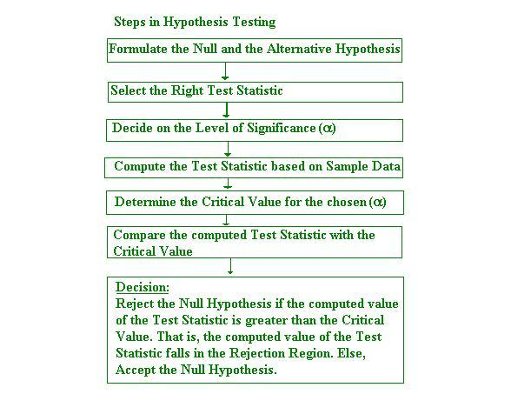

The discussion that follows will focus on formulating and testing hypotheses. First, we will focus on the formulation of the null and the alternative hypothesis that are very crucial for decision making. This is discussed in the next screen.

Glimpses into Formulating the Null and the Alternative Hypothesis

The trickiest part in the entire exercise of hypothesis testing is the formulation of the null and the alternative hypothesis. You must spend a great deal of time in mastering the formulation part.

A hypothesis could be directional or non-directional. A directional hypothesis is one in which the population parameter is structured to be greater than or equal to or less than or equal to a specified value. This is known as a one-tailed test(one-sided test) in the parlance of statistical hypothesis. A non-directional hypothesis is one in which the population parameter is structured to be equal to a specified value. This is known as a two-tailed test(two-sided test).

To clarify these ideas, first, let us explain the formulation of the null and alternative hypothesis for the univariate case through some examples. Then we will move on to the procedures for conducting hypothesis testing. This will involve the entire gamut of structuring the hypotheses (null and alternative), step-by-step procedure for accepting or rejecting the hypotheses. As you know, acceptance or rejection of a hypothesis leads to acceptance or rejection of a particular decision.

8.2 Hypothesis Testing –Univariate Case (One Sample)

Hypothesis Testing –Population Mean (Single Mean)

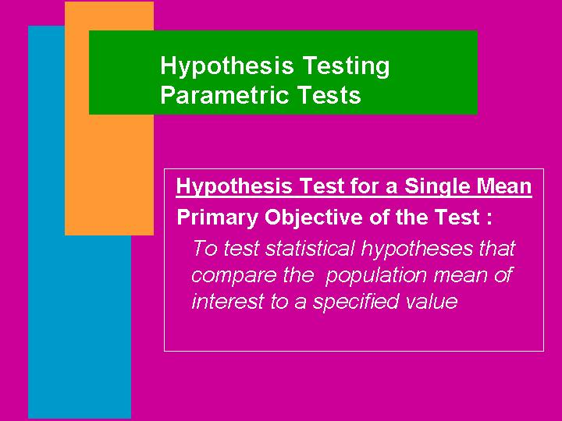



Look at the illustration above. Can you say it is a one-tailed test or a two-tailed test? It is a one-tailed test because the population waiting time of customers at the checkouts of Smart Supermarket is specified to be greater than 15 minutes. Can you formulate the null and the alternative hypothesis for this illustration? First, try on your own. The formulation is given in the next screen.

Structure of the Null and Alternative Hypothesis for the Illustration

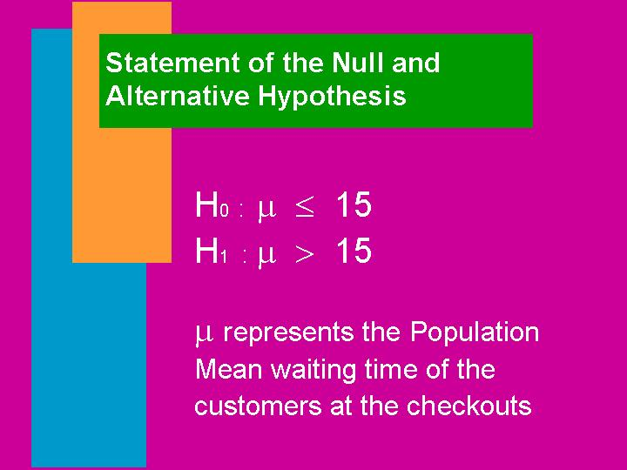

The null hypothesis H₀ is generally the negation of the truth. The question that is raised about the population mean is ”is the waiting time greater than 15 minutes”. So, it is a one sided test and the right structure is that the null hypothesis must specify the population waiting time at the checkouts to be less than or equal to 15 minutes. Consequently, the alternative hypothesis H₁ is that the mean waiting time is more than 15 minutes. This is precisely what is formulated in the diagram above. The formulation of the directional hypothesis (one-tailed) is a frequent problem among the students and practitioners. You will be correct in your formulation, if you remember two things. 1) The null hypothesis is formulated with a view to getting it rejected. 2) Generally we always feel and suspect that the alternative hypothesis will happen. Take this example. It is suspected that the waiting time in the checkouts is more than 15 minutes. That is you strongly feel that this is happening. So, this is the alternative hypothesis. Are you getting it right? Good. The other principle to be followed is that read the problem situation given meticulously. You will never go wrong in formulation. I am 99% confident that you can formulate the null and the alternative hypothesis correctly if you faithfully follow the tips given above.

Please note that in any problem, the alternative hypothesis will be always be strictly greater than or strictly less than or strictly not equal to form. It will never have an equality sign.

Inline question

In the supermarket example given above, if the question were rephrased as “is the average waiting time of the customers at the checkouts different from 15 minutes”, how would you formulate the null and the alternative hypothesis?

Solution:

H₀: μ = 15 (the average waiting time of the customers is equal to 15)

H₁: μ ≠ 15 (the average waiting time of the customers is not equal to 15)

This formulation is undoubtedly a two-tailed test of hypothesis. Can you say why? The population mean waiting time is specified to be equal to the value10. Therefore it’s a clear case of two-tailed test. Are you getting more and more confident in formulating the null and the alternative hypothesis? Good.

With the experience you have gained with regard to the formulation of the null and the alternative hypothesis, let us now move on to formulating the null and the alternative hypothesis for problems relating to the population proportion.

Hypothesis Testing-Population Proportion (One sample)

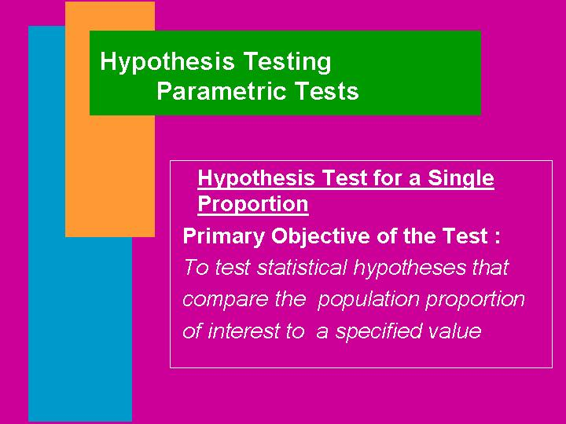

Let us look at an example for formulation of the hypotheses in the case of the population proportion in the next screen.

Population Proportion-Hypothesis Formulation An Illustration

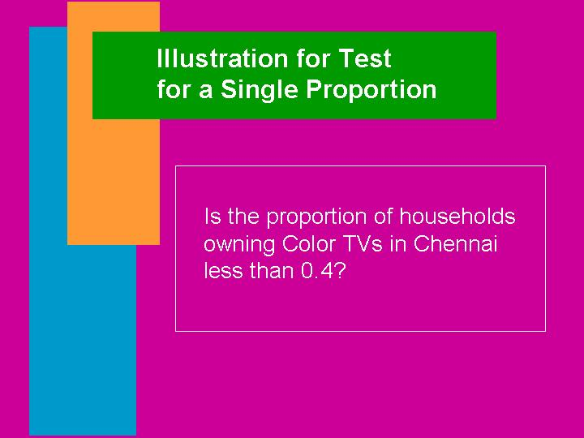

Can you say the illustration above is an example of what type of test? You must of course say that it is a one-tailed test. First try to formulate the null and the alternative hypothesis yourself. The correct structuring of the null and the alternative hypothesis is given below:

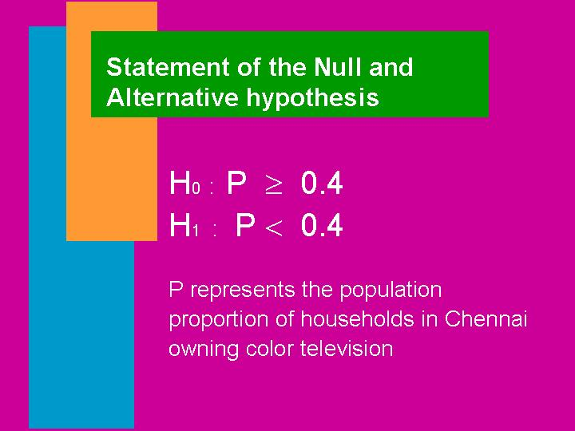

How does Hypothesis Testing work in Practice?

1) Population Mean - (Univariate)

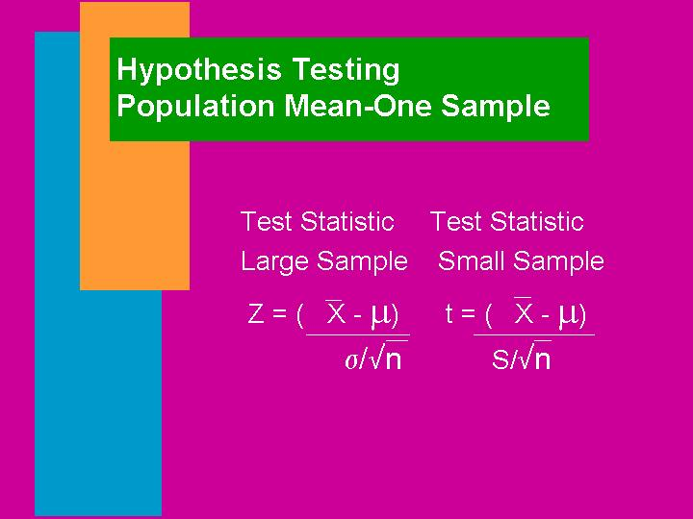

The best way to understand and apply the concept of hypothesis testing for the population mean is through an example. First we take the case of large sample.

The marketing manager of a large restaurant has been asked to conduct a survey of its customers belonging to a particular income class. The president of the restaurant is interested in the mean income of its customers. He is further interested in comparing this mean income with that of a recently concluded census study by the government. The government study shows a mean income of Rs.300000 per year for this class of customers with a standard deviation of Rs. 10000. The president is desirous of finding out whether the population mean of its customers in this category is Rs. 300000 per year or not. The marketing manager has picked up a random sample of 100 customers of this class from the customer database. The sample data show a mean income of Rs. 290000 per year. Perform a comprehensive statistical hypothesis testing procedure and state your conclusions.

Solution: By carefully reading the situation, you will be able to recognize this problem as a two- tailed test of hypothesis. Let us solve this problem step-by-step.

Step 1: Formulate the null and the alternative hypothesis.

H₀: μ = 300000 (the mean income of the population is equal to Rs.300000)
H₁: μ ≠ 300000 (the mean income of the population is not equal to Rs.300000)

Step 2: Select the right test statistic. The correct test statistic to be used here is the Z test. Why? Because, the sample size is large. The formula for the Z test is given below: Please note that Z follows a standard normal distribution with mean 0 and standard deviation 1.
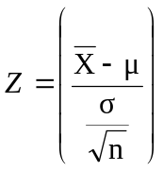

Step 3: Decide on the level of significance α. When the value of the level of significance is not specified in a problem, it is a convention to set the value equal to 0.05. What we’re saying is that only 5% of the time we make the mistake of rejecting the null hypothesis when it is true.

Step 4: Compute the test statistic based on sample data. The formula to be used is
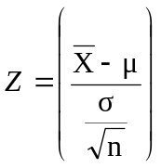. Under the assumption of the null hypothesis being true, you can substitute the value Rs. 300000 in the place of . 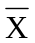 =290000. n =100. = 10000.
Upon substitution of these values in the formula, we have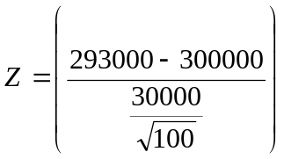 =
-2.33.

Step 5: Determine the Critical Value for the chosen level of significance. Here, α =0.05. The critical value corresponding to the two-tailed test where each tail contains an area of α/2 can be easily worked out by using Microsoft Excel. The methodology is already covered in the previous modules. Here, α/2 =0.025. The critical value of Z =1.96 for positive Z and –1.96 for negative results. Since the normal distribution is symmetrical, we can ignore the sign of Z and just take the positive value of Z. That is the critical value of Z is 1.96. Incidentally, if you choose α =0.01, then the critical value of Z =2.58.

Step 6: Compare the computed test statistic with the critical value. Here, computed Z =
-2.33. Since the normal distribution is symmetrical, take the positive value of Z and compare it with the Critical Z =1.96. If you take the negative computed Z, then compare it with –1.96. Take the positive Z. Simple is best. Why bother?

Step 7: Decision. If the computed Z is greater than the table Z, reject the null hypothesis H₀ and accept H₁. Else accept H₀. This is same as finding out whether the computed Z falls in the acceptance region or the rejected region. In our case, computed value of Z (take just the positive value) 2.33 is greater than the critical value of Z =1.96. Hence, it falls in the rejection region. Reject H₀ and accept H₁. For better grasp, see the following diagram giving the acceptance region and rejection region for a level of significance of 0.05 for a two-tailed test.
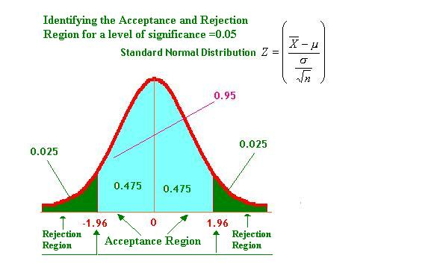

Are you able to see now that the computed Z for our example problem =2.33 falls in the rejection region in the diagram above? You must say yes with 95% confidence level if not 99%. The simple rule is that if the computed Z is greater than the critical Z, reject the null hypothesis.

Interpretation of the Results for our example:

We have rejected H₀ and accepted H₁. What does this mean? This means that the population mean income of the category of interest to the president of the restaurant is not equal to Rs. 300000 per year at 5% level of significance. Is it more than or less than Rs. 300000? The sample mean suggests that it may be less than Rs. 300000 per year. Can you do this exercise now as a one-tailed hypothesis test? This is an inline question for you.

P-Value:

Some software packages like SPSS and Excel talk about a P-Value. P –Value gives the actual level of significance at which the null hypothesis can be rejected. if P-Value is smaller than the level of significance stipulated, reject the null hypothesis. What does it mean? You see, you have chosen α =0.05. This means that you are rejecting the null hypothesis when it is true only 5% of the time. When the P-value is smaller than 5%, is it not obvious that you have to reject H₀? Yes. Why? Because, it implies that the probability of rejecting the null hypothesis when it is true is smaller than 0.05.You are willing to take a risk of 5%. Now, the risk is even smaller. Naturally, you will reject H₀. Both the methods of deciding whether to accept or reject H₀ are the same. It is a matter of your own convenience.

Inline Question:

What is the P-value corresponding to the computed Z = -2.33 in our example?

Solution:

P- Value = Probability of Z less than -2.33. Using the Microsoft Excel you just compute the cumulative probability using Z = -2.33 in the paste function. As you can see from the output below, the P-Value is =0.0099. This is smaller than the level of significance =0.05. Hence, Reject H_{0.}

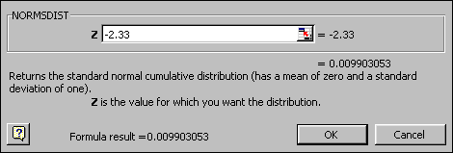

Inline Question:

For the same illustration discussed, if the president of the restaurant wants to find out whether the mean income of the customers is less than 300000 per year, perform the hypothesis testing using the same data.

Solution: This is clearly a case of one-tailed test. The test statistic to be used is Z statistic. Up to computing Z, every thing remains same. While comparing the computed Z with the critical Z, you need to get the critical Z for the one-tailed test.
The hypothesis formulation is as follows:

H₀: μ ≥ 300000
H₁: μ < 300000
As before = = -2.33.
If we take the one-tailed test, the critical Z from Microsoft Excel corresponding to α =0.05 =1.65. The computed value of Z taking only the positive value =2.33 is greater than the critical Z =1.65. Reject H₀ and accept H₁. This means that the population mean income of the customers is less than Rs. 300000 per year at 5% level of significance. See the following diagram depicting the acceptance and rejection region for the one- tailed test.

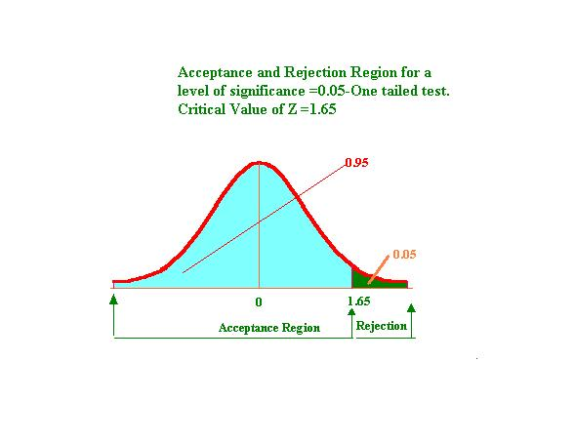
2) Population Proportion-Large Sample (Univariate)

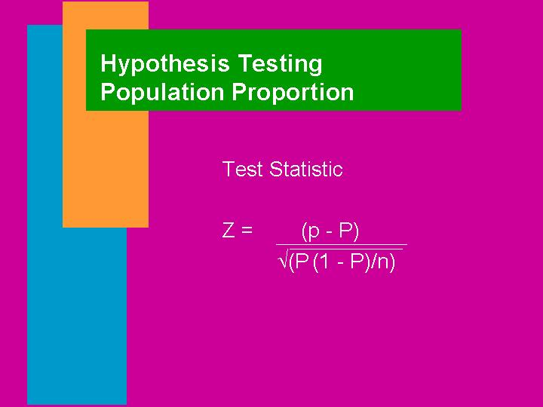

Example: A marketing manager of an enterprise is facing a decision whether to introduce a new product into the market or not. Consumer acceptance measured in a blind comparison test is agreed upon as an appropriate basis for evaluation. Marketing of the new product will be pursued only if the acceptance rate exceeds 30%. Otherwise, the new product will not be introduced in the market. A random sample of 200 consumers reveals that the acceptance rate is 32%. Using a level of significance of 0.05, perform the hypothesis testing and recommend your action. Solution is given in the next screen.

Solution: This is a classical hypothesis-testing problem of the population proportion. This is also a one-tailed test. This involves a large sample in which n =200. The Z test for the proportion is the appropriate test.

H₀: P ≤ 0.30 (The population proportion of consumer acceptance is less than or equal to 0.30)
H₁: P > 0.30 (The population proportion of consumer acceptance is greater than 0.30)

The Z test for proportion is to be used here. It is given by 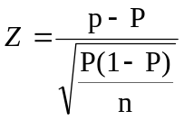. Please note that Z follows a standard normal with mean 0 and standard deviation 1. Under the null hypothesis being true, P=0.30. p=0.32. Substituting, we have
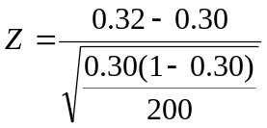= 0.62.
The critical value of Z for a one-tailed test is 1.65. Please see the diagram giving acceptance and rejection region we have drawn for testing the population mean. The same diagram holds true in the case of proportion as well. Since, the computed Z is less than critical Z, accept H₀. What do you conclude?

We have no evidence to reject the null hypothesis based on the sample data at 5% level of significance. In this case even at 1% level of significance, we cannot reject H₀. This implies that you accept H₀ and conclude that the population proportion of consumer acceptance is less than or equal to30%. Hence, the manager should not introduce the new product in the market. You may wonder how come when the sample proportion is 32%, you say that you should not introduce the new product? Is not 32% better than the 30% stipulated? Yes, but you see statistically speaking, 32% sample proportion has arisen due to chance and not a real one. This is why you say statistically not significant. As long as statistical significance does not take place, you cannot reject the null hypothesis. This is a real beauty of testing of hypothesis. Unless the manager wants to gamble, he should not venture to introduce the new product.

3) Population Mean-Small Sample (Univariate)

As you may recall from the previous module, the role of t distribution in setting up the confidence interval for the population mean when the sample size is small and the standard deviation is unknown. The same t distribution with n-1 degrees of freedom will apply in hypothesis testing as well. Please also see the test statistic for t given in the picture under small sample just before commencing the example for the population mean –large sample case. The procedure for conducting the hypothesis testing will be exactly same as the one we followed for the large sample case except the test statistic. Let us look at an example.

Example: An investigator took a random sample of eight pieces of aluminum die-castings and observed the sample mean strength to be 31.5. Before taking the measurement, the investigator knew that the population mean strength for an older type of aluminum die-casting was 33. The standard deviation of the sample measurements was 1.3. The investigator would like to know whether the population mean strength of the aluminum die-casting is 33. Setup the null and the alternative hypothesis, perform the test, and comment on the results.

Solution:
This is a small sample case with unknown population standard deviation. The appropriate test is the t test. Please note also from the wording of the problem, you need to perform a two-tailed test. Just like the normal distribution, t is also symmetrical and it is enough if you compare the positive value of the computed t with the critical t for n-1d.f at 5% level of significance.

H₀: μ =33
H₁: μ ≠33
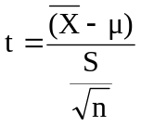 = 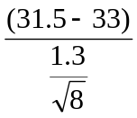 = -3.26. The positive value of the computed t =3.26
The critical t value for 7d.f(n-1 =8-1) at 5% level of significance from Excel paste function is 2.36(2 places of decimal). Since the calculated t value is greater than the critical t, reject H₀ an accept H₁. The conclusion is that the mean strength of aluminum die casting of the population is not 32 at 5% level of significance.

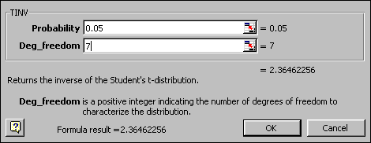

Inline Question: For the same illustration above if the investigator wants to find out whether the population mean strength of the die-casting is less than 33, how would you perform the t test?

Solution: From the wording, it is clearly a one-tailed test. The hypotheses structuring should be as follows: The investigator suspects that the mean strength is less than 33.(This will be H₁)

H₀: μ ≥ 33
H₁: μ< 33
As before, = = -3.26. The positive value of the computed t =3.26
The critical value of t at 5% level of significance for a one tailed test with 7 d.f is to be found out from Excel. First click paste function, then click Statistical, then click TINV, you get



Click OK and then enter the values in the asked cells. When you want the t value at 5% level for a one-tailed test, enter double the value of 5% that is 0.10 in the probability cell to get the t value for the one-tailed test. This is the trick you have to play. In other words, for a two-tailed test, enter the probability value as it is (=level of significance) and for the one-tailed test, just double it. You are able to do this because t is symmetrical. Since, the computed positive t(3.26) is greater than the critical t(1.89), reject H₀ and accept H₁. That is the population mean strength of die-cast appears to be less than 33 at 5% level of significance.
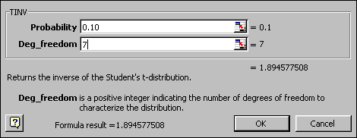

8.3 Hypothesis Testing –Bivariate Case (Two Sample)

In many decision-making situations, we need to examine whether the means of two populations are same or different. The production manager in a company may wish to test whether the female workers give lower outputs than the male workers. A human resource director may be interested in finding out whether the hourly professional charges by two trainers are the same in two cities. A marketing manager may wish to estimate the difference between men and women with regard to the per capita consumption of a product. Therefore, you need hypothesis testing procedures for comparing two population parameters. Extending the discussion to more than two parameters is possible and will be discussed in the next module.

Hypothesis Testing - Two Population Means
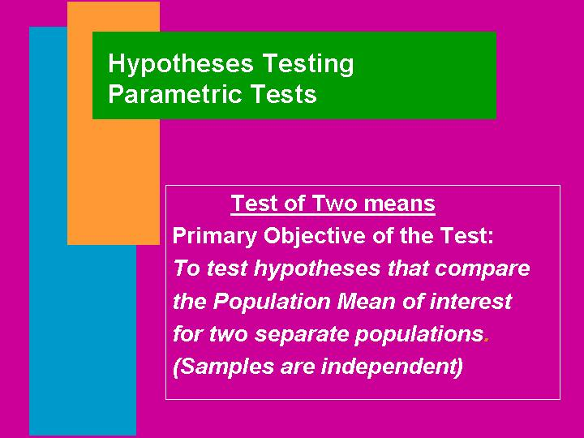

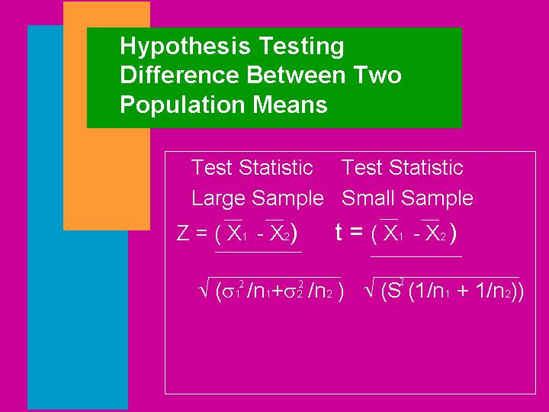

A Brief Note on the Test Statistic(s)

- The sampling distribution of the difference between the means of the two populations is of interest to us.

- We take a random sample of n₁ observations from population 1 and n₂ observations from population 2 and compute the difference between the sample means 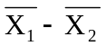. If we generate the distribution of all possible 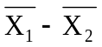, will follow a normal distribution with mean 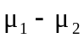 and standard deviation 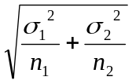 when the sample size is large(both n₁ and n₂ are greater than or equal to 30). is called the standard error of 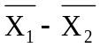.

- If the two population standard deviations are not known, we can estimate the standard error of by substituting with the sample standard deviations. That is 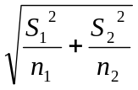will be used in the place of .

- The Test Statistic Z = 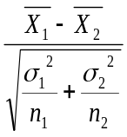. Z follows normal with mean 0 and standard deviation 1.

- If the original populations are assumed to be normal with standard deviations are equal, the appropriate test statistic is t. This is also to be used when the sample size is small.

- The test statistic t =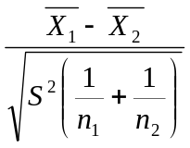. This follows a t distribution with

- n₁+n₂-2 degrees of freedom. S² is called the pooled sum of square variance given by 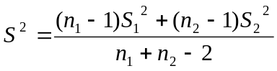. S₁² and S₂² are the variances of the samples taken from the two populations.

Difference Between Two Population Means- Large Sample

Example: A test in computer course was conducted for a group of students, consisting of 70 boys and 60 girls. The marks scored by the students are given below:
Boys | Girls
n₁ = 70 | n₂ = 60
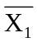 = 70 | 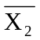 = 65
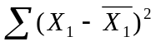 = 7,500 | 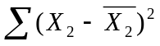= 7,800

Is there a significant difference between the performance of the boys and the girls?

Solution:

From the wording of the question, it is clear that the problem could be structured as a two-tailed test. The sample sizes for both the populations are large and hence the Z test is appropriate to use. Let us take a level of significance of 5%.

H₀: μ₁ = μ₂ ( The population mean score of boys =The population mean score of girls)

H₁: μ₁ ≠ μ₂ ( The population mean score of boys ≠ The population mean score of girls)

Z = 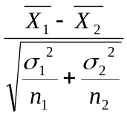. The standard deviation of the two populations are not given. We can use the sample standard deviations in the place of the population standard deviations. That is use in the place of . In the data for the problem, we are given =7500 and = 7800. By definition 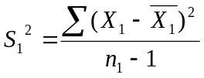 and 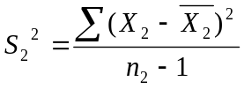. Substituting and simplifying we have
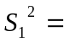 (7800/69) = 113.04 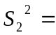(7800/59) =132.20.

Z =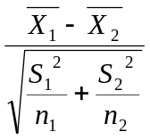 =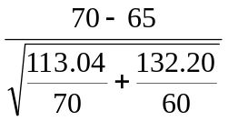 =2.56.

What is your decision? The procedure is exactly the same as the single mean case. If the calculated value of Z is greater than the critical value of Z at 5% level, reject H₀ and accept H₁.The critical value of Z at 5% level is 1.96 for a two-tailed test.

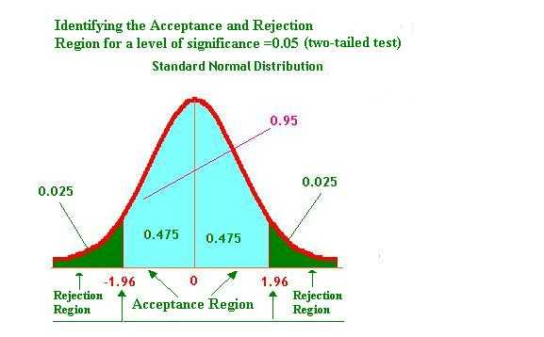

In our example, calculated Z is greater than the table Z. Reject H₀ and accept H₁. That is the performance of the boys and the girls are not identical. The null hypothesis of equally good performance is rejected. The difference in the mean scores between boys and girls is significant.

Inline question: In the same example discussed, if the objective is to examine whether the boys are better than girls in performance, how will you modify the null and alternative hypothesis? What are your conclusions?

Answer: The situation becomes a one-tailed test.

H₀: μ₁ ≤ μ₂ (Mean score of boys is less than or equal to girls)

H₁: μ₁ > μ₂ (Mean score of boys is greater than girls)

Every thing remains same except the critical value of Z. For a one-tailed test the critical value of Z for a level of significance of 5% =1.65.

Z = = =2.56.

The calculated value of Z is greater than the critical value of Z. Reject H₀ at 5% level and accept H₁. The conclusion is that boys perform better than girls.

Difference Between Two Population Means- Small Sample

Example: An Aptitude test was conducted for two groups of excecutives-group1 consists of engineers and Group2 consists of accountants. The scores obtained by the candidates are given below:

Engineers | 125 | 115 | 119 | 85 | 97 | 107 | 125 | 125 | 118
Accountants | 112 | 98 | 109 | 96 | 77 | 70 | 114 | 100

Do you find any significant difference between the scores of these two groups?

Solution:

This is situation requires a two-tailed hypothesis testing. The sample sizes are small. n₁ =10 and n₂= 9.

H₀: μ₁ = μ₂ ( The IQ scores of both the groups are equal)
H₁: μ₁ ≠ μ₂ (The IQ scores of both the groups are not equal)

Let us take a level of significance of 0.05. This type of hypothesis problem can be easily solved using Microsoft Excel when the actual sample measurements are given: This is a real beauty.

Step1: Enter the data in the spreadsheet. The screen will be



Step 2: Click Tools, click Data Analysis and then click t-test two samples assuming equal variances. You now get

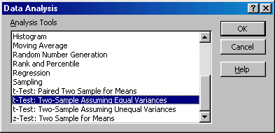

Step3: Click ok. Excel will ask you to enter input range for variable 1 and variable 2. For illustration purpose, how to enter input for variable 1 is given.

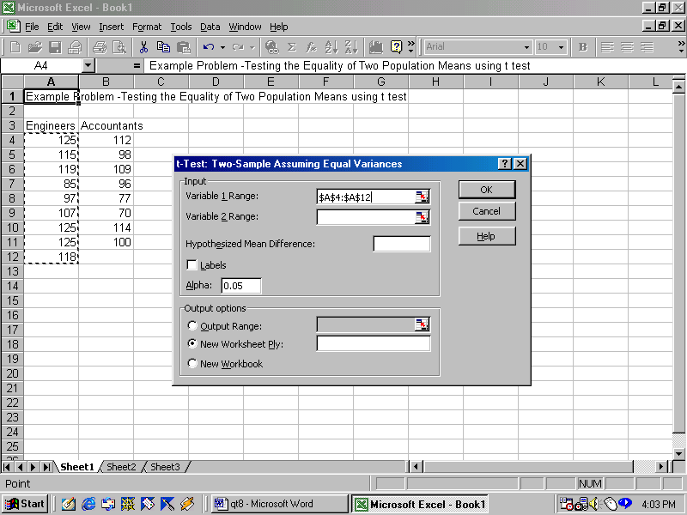

After entering the input range for variable 2, click ok. You now get the answer.

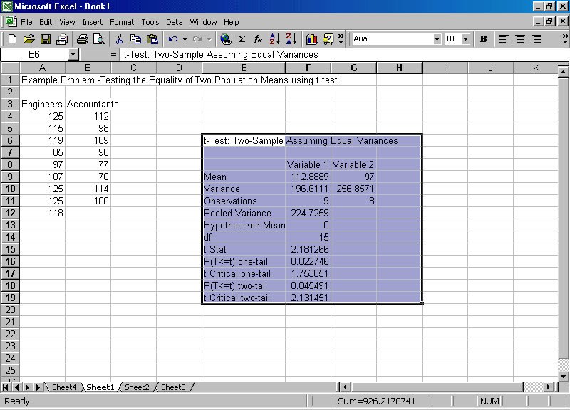

You name any thing. It is there. Hypothesized mean =0 implies ( μ₁ - μ₂ =0 that is same as μ₁ = μ₂). As you can see that the computed t is 2.18. It is greater than the critical t for the two-tailed test =2.13. Reject H₀ and accept H₁. We conclude that the mean scores of the engineers are not the same as the mean scores of the accountants. By default, Excel takes a level of significance of .05. See the previous screen. The facility of using the t test as well as Z test in Microsoft Excel is possible if you have the actual sample measurements.

Inline Questions:

1) For the same example, if you wan to find out whether engineers are doing better than the accountants, how will you frame the null and alternative hypothesis? What is your conclusion?

2) What is the P-value corresponding to the one tailed-test?

3) What is the P-value corresponding to the two-tailed test?

For better clarity the output of the previous screen is given below:
Solution:

1) H₀ : μ₁ ≤ μ₂
H₁: μ₁ > μ₂

The computed t Statistic =2.18. The critical t for 15 d.f for the one-tailed test is1.75. Reject H₀ and accept H₁. We conclude that the engineers have faired better than the accountants at 5% level of significance.

2) P-value for the one-tailed test is 0.0227 from the output above
3) P-value for the two-tailed test is 0.0455 from the output above

Difference in Two Population Means-Small Sample(Dependent Sample)

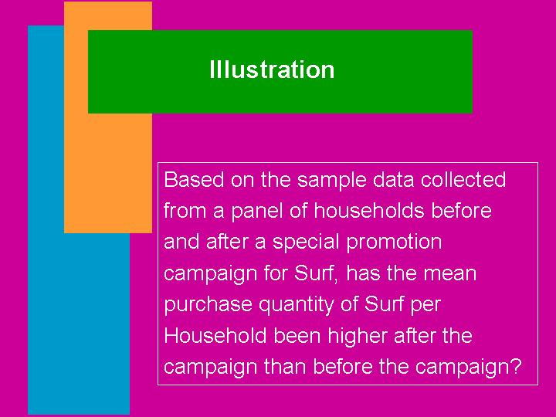

A situation like the one shown above can be answered by the t-test when the sample size is small and the measurements are taken before and after situation for the same sample. This t is called the paired t and follows a t distribution with n-1 d.f. Please note that the sample size for both the measurements must be equal to n.

The hypothesis formulation and the test statistic are given below:

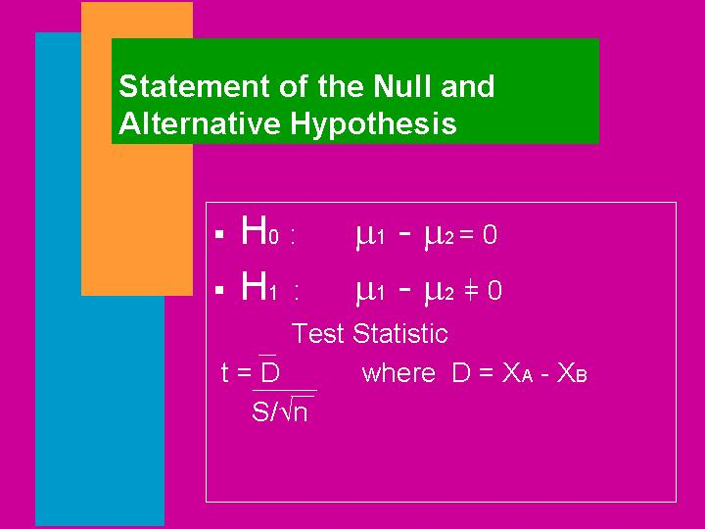

X_{A} =Measurement after the situation
X_{B} =Measurement before the situation

Paired t Test- Example.

A company conducted a promotional campaign in 10 randomly chosen retail outlets. Monthly sales in 1000 units are shown before and after the campaign. Is there any significant difference in sales before and after the campaign?

Outlet No | Before the Campaign | After the Campaign
1 | 240 | 270
2 | 225 | 245
3 | 250 | 260
4 | 280 | 290
5 | 200 | 190
6 | 150 | 160
7 | 165 | 160
8 | 100 | 130
9 | 130 | 135
10 | 170 | 175

Solution: This is a two-tailed hypothesis problem. Let us take a level of significance of 0.05. The appropriate test statistic is a paired t for the dependent sample.

H₀: μ₁ = μ₂ (The means sales are same before and after the campaign)
H₁: μ₁ ≠ μ₂ (The mean sales are not same before and after the campaign)

We can obtain the solution easily from Excel. After the data entry, the screen looks as follows:


Click Tools, Click Data Analysis, and then click t-test for paired two sample for means, you get

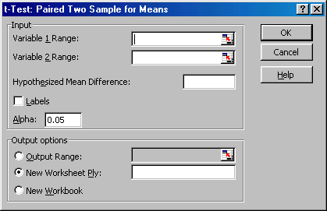

Enter the input for variable 1range and variable 2 range and then click ok. You get the answer. Now look at the output. You infer the following.


The calculated t value is –2.51197. As Excel subtracts the sample mean 2 from sample mean, the t statistic is negative. t distribution is symmetrical. The positive computed value of t =2.51. T critical for a two tailed test =2.26. Reject H₀ and accept H₁. The mean sales are not the same before and after the campaign. Using a one sided test, it is easy to conclude that the promotion is effective in increasing the sales.

Assignment:

For the illustration above, if the company wants to find out whether the campaign has boosted the sales, how would you formulate and test the hypothesis? Use a level of significance of 5% and 1%. It is mandatory that you use only Microsoft Excel.

Difference between Two Population Proportions:

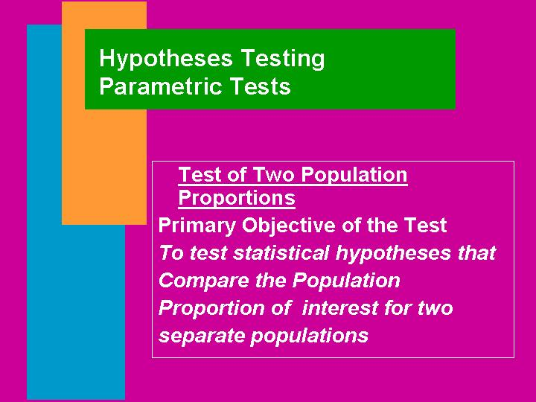

Just like the sampling distribution of the difference in means, the difference between two sample proportions follows a normal distribution when the sample size of both the populations is large (greater than or equal to 30). The test statistic to be used is given by

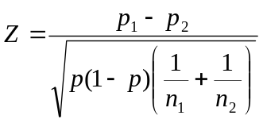. This follows a normal with mean 0 and standard deviation 1.
p₁ is the sample proportion to estimate the population proportion P₁.
p₂ is the sample proportion to estimate the population proportion P₂.

p is the combined mean of p₁ and p₂ with weights n₁ and n₂. That is 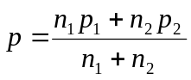.

The decision rule is the same. That is the calculated value of positive Z is greater than the critical Z, reject the null hypothesis and accept the alternative hypothesis. The critical Z for 5% level and 1% level for the two-tailed test are 1.96 and 2.58 respectively. Also for a one-tailed test, the critical value of Z is 1.65 for a level of significance of 5%. Don’t memorize. Use Microsoft Excel to get these values.

Example: Two random sample surveys, conducted with two months gap between the two, assessed public opinions on the outcome: The question that was posed was “If the general election was going to take place tomorrow, would you cast your vote for or against the ruling party?”

The results of the two surveys are tabulated below:
 | 1st survey | 2nd Survey
Sample size………………… | 1000 | 800
For the ruling party…………… | 520 | 380
Against the ruling party……… | 480 | 420

Set up the appropriate hypotheses, test and draw your conclusions.

Solution: This requires a structuring of the null hypothesis as no change in pattern of voting between the two months by the public. Symbolically

H₀: P₁ =P₂ (The population proportions favoring the ruling party in the two months gap is the same)

H₁: P₁ ≠ P₂ (No. It is not the same).

Let us take a level of significance of 5%. It is a two-tailed test and therefore critical value of Z =1.96.

The test statistic . First let us calculate p.

=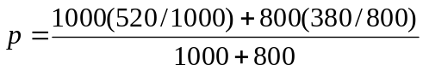=0.50.

=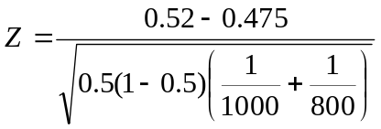=1.34

The calculated value o Z is less than the table value of Z. Accept H₀. The inference is that the population proportion of the public favoring the ruling party in the two months gap has not changed at a level of significance of 5%.

9.4 Module Summary

This module has introduced you to the nitty-gritty of Hypotheses Testing with conceptual rigor and decision orientation. In particular, this module focused on:

- The definition and meaning of statistical hypothesis

- Conceptual foundation of the null and alternative hypothesis

- Type I and Type II error and their relationship with confidence level and power of the test respectively

- How to formulate the null and alternative hypothesis for the one-tailed and two-tailed test

- How the hypothesis works in practice as a decision making tool

- One sample tests for the population mean using Z test for the large sample and t test for the small sample.

- One sample test for the population proportion using Z test for the large sample

- Two sample tests for the difference between two population means, and two population proportions using the Z test.

- Two sample tests for the difference in population means using the t test for small sample when the samples are independent

- Paired t test for the dependent sample (before and after situation type)

- How to apply Microsoft Excel in appropriate tests.

Glossary:

Alpha (α): The probability of making a Type I error is called the level of significance of the test. It is designated by the Greek letter alpha α.

Alternative Hypothesis: The conclusion we accept when the null hypothesis is rejected.

Beta (β): The probability of making a Type II error is symbolized by the Greek letter β.

Critical Value: It is the standard value of the test statistic for a given level of significance that is used to decide whether to reject the null hypothesis or not.

Hypothesis: A hypothesis is a statement about a population parameter. It may or may not be true.

Level of Significance: It is the probability of rejecting the null hypothesis when in fact it is true.

Null Hypothesis: It is the hypothesis that is always tested. It is so formulated that its rejection leads to the desired conclusion.

One-Tailed Test: It is a directional hypothesis in which the population parameter is structured to be greater than or equal to or less than or equal to a specified value.

Power of the Test: It is the probability of rejecting the null hypothesis when in fact it is false.

Two-Tailed Test: It is a non-directional hypothesis in which the population parameter is structured to be equal to a specified value.

Type I Error: Rejecting a null hypothesis when in fact it is true.

Type II Error: Accepting a null hypothesis when in fact it is false.

